Shape Bar chart

Connect to the superstore data source and copy paste Model data and create a cross join using edit join feature.

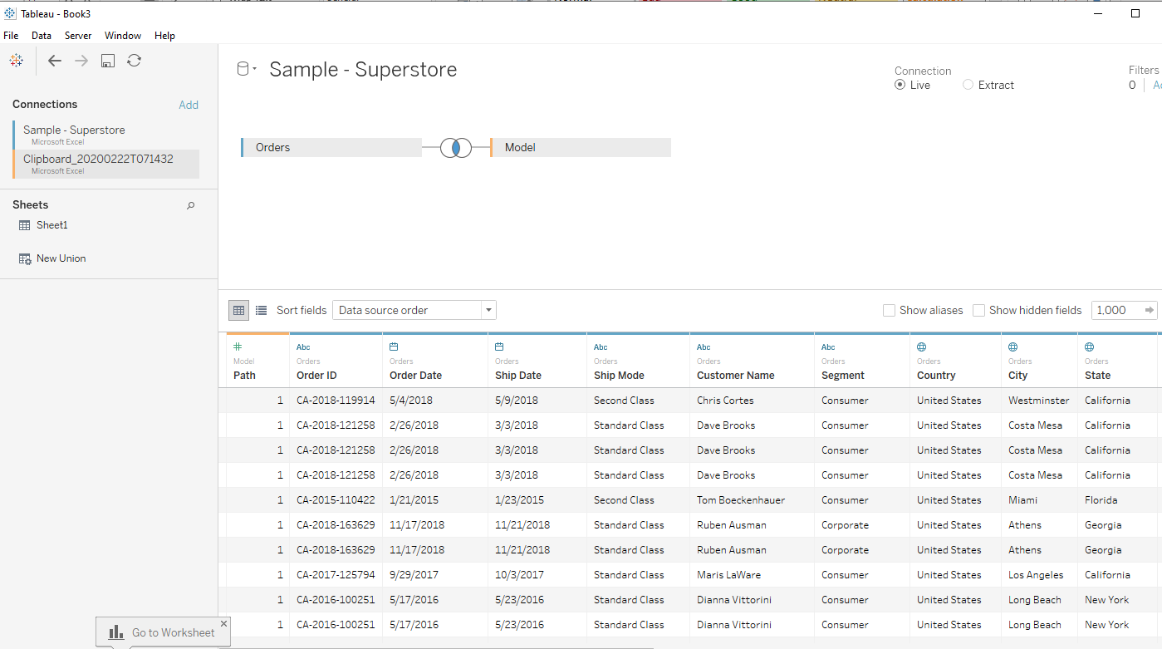

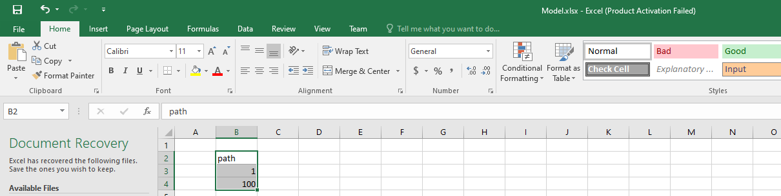

Create a new parameter

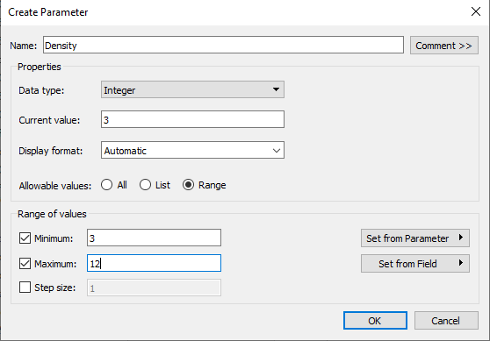

Create a bin for path and change the size of Density

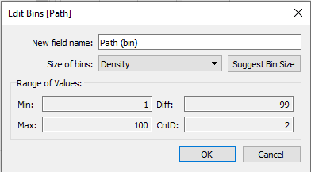

Change the marks to color and drag path(bin) to the details shelf.

Create the following calculated fields

Index

(INDEX()-1)/100

TC_sales

WINDOW_SUM(SUM([Sales]))/2

TC_total sales

WINDOW_SUM(SUM([Sales]))/2

TC_percentage of total sales

[TC_sales]/[TC_total sales]

Drag Sub-Category to the rows shelf and index to the columns shelf and change the compute using for the index to path(bin). Uncheck the show header.

Create the calculated fields

TC_percentage of total sales(adjusted)

[TC_percentage of total sales]/WINDOW_MAX([TC_percentage of total sales])

TC_color

IIF([index]/WINDOW_MAX([index])<=[TC_percentage of total sales(adjusted)],"Color","Empty")

Drag TC_color to the color shelf and compute using path(bin) and edit the table calculation for To_color as follows.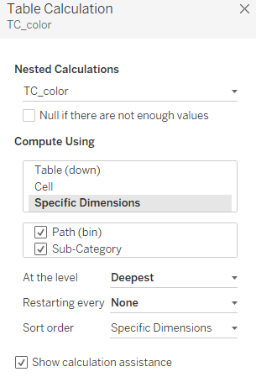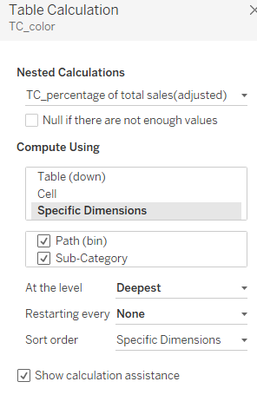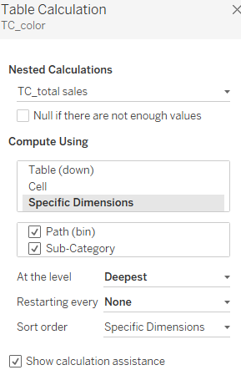

Then on the marks shelf change the TC_color to shape and edit the shape and control click and drop the shape again to the color shelf and edit the color as desired.

Drag TC_sales and TC_percentage of sales on the columns shelf and change the type to discrete and format as desired.

The final chart

